Frequently
Asked Questions
What happens when my business receives an audit notice or letter?
As soon as you receive a notice or audit letter from the IRS, give us a call immediately so we can start resolving the matter.
How long will you defend my return?
We will defend your current year tax return for as long as it can be audited (generally three years).
Will you offer this plan every year?
Yes. We plan to continue to offer our Audit Protection Plan every year.
What happens if I don’t file on time?
Your Audit Protection Plan covers tax returns that were filed late.
What happens if I need to file an extension?
Every tax return covered under the Audit Protection Plan, including extensions, will be covered under the plan.
Is my amended return eligible for protection?
Yes. Amended returns are also covered under your Audit Protection Plan.
What if I have multiple state returns?
All related state returns are also covered under the Audit Protection Plan.
What is your guarantee?
You may cancel your Audit Protection Plan for any reason within 30 days of signing up.
Can I purchase an Audit Protection Plan for any type of tax return?
You can purchase an Audit Protection Plan for the following types of tax returns:
- Form 1040 - Individual
- Form 1120 or 1120S - Corporation
- Form 1065 - Partnership
Your Business
Peace of Mind
Audit Protection Plan
Also Includes
Tax Identity Fraud Recovery …
Tax Identity Fraud is on the rise. In the past two years alone, more than 1,500,000 Americans had their tax identity stolen, with $6.2 billion that was fraudulently claimed. So, yes, it happens a lot more than you realize. How are you supposed to prove that you are you?
The Audit Protection Plan will give you full tax identity recovery and audit representation protection on your business if you get any notice from the IRS. It will shield you from the time, money, and frustration you will undergo if you try to resolve these issues yourself.
Your Time Is Valuable.
Don’t Let The IRS
Disrupt Your Life!

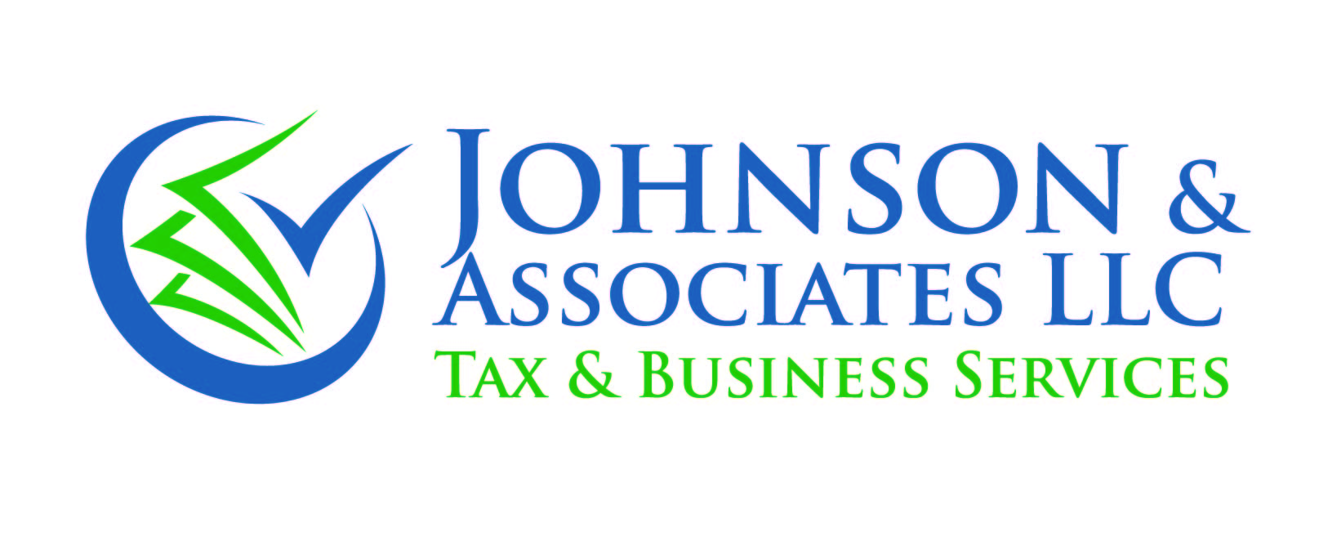
2351 Sunset Blvd, Suite 170-260,
Rocklin, CA 95765

2351 Sunset Blvd, Suite 170-260,
Rocklin, CA 95765

Call: (916) 539-7330
Email: thetaxman411@gmail.com
Visit: www.taxservicesforall.com
If You Received A Notice Would
You Know What To Do?
You go to your mailbox, pull everything out looking for something more exciting than junk mail, and there it is … an envelope with the return address “Internal Revenue Service” on it.
Your heart starts to race, and you break out in a sweat. You open it and it’s a notice that the IRS is either questioning items on your business tax return, or you’re going to be audited. Worse yet, you find out someone stole your identity, filed a tax return in your name, and collected a fraudulent refund!
You might wonder why you received the letter from the IRS in the first place since you have your tax returns prepared by a professional. The truth is anyone is subject to the scrutiny of the IRS for a variety of reasons.
Of course, if we do make any error, we will correct the issue and take responsibility for any penalties or actions with the IRS.

The Audit Protection Plan
For One Low Fee …
With our Business Audit Protection Plan we’ll protect you from ever having to deal with the tax authorities by yourself in case you get a notice from the IRS. And if you are ever summoned to meet with an IRS agent in person, we’ll attend on your behalf!
All this happens without any extra charges to you.
Isn’t that a relief?
Sure, You Can Roll
The Dice And Pass Up
This Protection …
Without our Audit Protection Plan in place, receiving an audit notification will cost you anywhere from $3,500 to $10,000 and up to have a licensed tax professional defend you in an audit.
Here are the facts: The IRS sent out more than 9 million automated notices last year. When you receive a letter from the IRS, they will claim you owe them money or claim you didn’t report something properly, which you will have to defend, because with the IRS you are guilty until proven innocent. They have the power to levy your bank accounts and garnish your wages without a court order!

The Audit Protection Plan Will Save You Time And Money …
For a small fee that’s added to your tax preparation invoice, we’ll shield and protect your business from ever having to deal with the tax authorities by yourself in the event you get a notice from the IRS or state tax authorities. And if you ever have to meet with an agent in person, we’ll attend the meeting on your behalf. You don’t even have to go!
You have the option to “opt out” of the plan if you choose; otherwise, you can agree to the protection by paying the fee. But if you choose to “opt out” of the Audit Protection Plan, you will be charged our usual hourly rates to handle any notices you receive from the IRS or State.
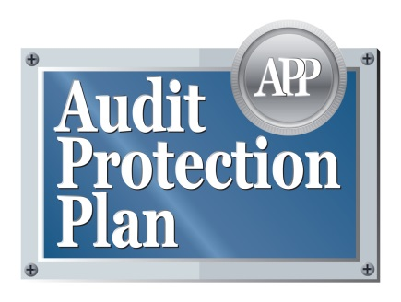
Member Benefits | Gold Membership  $299.95/Yr. | Silver Membership  $249.95/Yr. | Basic Membership  $209.95/Yr.
Correspondence Response
($300 Value)
Business Returns 1120/1120S/1065/
1041 IRS & State “Worry-Free” Audit Representation ($3,500 to $10,000 Value)
Tax Identity Fraud Remediation
Up to 1 Hour of Non-Covered Matters at
NO Additional Charge
($300 Value)
Four 15-Minute Phone Calls, and 2 Office Visits
($600 Value)
Priority Phone, Email, and Office Access
(Calls and emails returned within
24 hours)
Office Visits Scheduled Within the Same Week if Available

